TECHNOLOGY FOR GLOBALIZATION

Technology has been the key enabler of globalization — connecting people, markets, ideas, and capital across borders with increasing speed and efficiency. Here’s a structured overview of how technology drives globalization, including both traditional and emerging technologies:

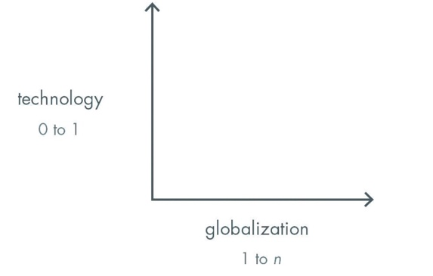 | 

🌍 1. Communication Technologies – Making the World Smaller

These reduce barriers of time and distance:

Technology Impact on Globalization
Internet Instant access to information worldwide
E-mail & Messaging Real-time communication across borders
Video conferencing (Zoom, Teams)
Collaboration business, education, diplomacy
Social Media Global cultural exchange, citizen diplomacy,
mass mobilization

🛫 2. Transportation & Logistics Tech – Moving Goods and People

These enable global supply chains and workforce mobility:

Technology Impact
Container shipping tech Efficient global trade
Air traffic systems Mass international travel
GPS & RFID tracking Transparent global logistics
Autonomous & drone delivery Potential for decentralizing global distribution

🧠 3. Data & AI – The Brain of Globalization

These allow for global-scale decision-making and optimization:

Technology Impact
Big Data & Analytics Cross-border market analysis, trend prediction
AI & ML Personalized services globally, smart translation
Natural Language Removes language barriers through
Processing (NLP) real-time translation

💱 4. Financial Technology – Borderless Capital Flows

These democratize access to financial systems:

Technology Impact
Online banking Global commerce and remittances
Digital payment platforms
(PayPal, Stripe, M-Pesa) Cross-border transactions
Blockchain & Crypto Decentralized finance, borderless digital assets

🛠 5. Platforms & Marketplaces – Global Economic Participation

These connect supply and demand globally:

Technology Impact
E-commerce platforms Global reach for sellers and buyers
(Amazon, Alibaba)
Gig economy platforms Global talent exchange
(Upwork, Fiverr)
SaaS tools Small companies can serve customers worldwide

🧬 6. Emerging Tech in Globalization

Technologies shaping the next wave of globalization:

Tech Example Use Case
Web3 & Blockchain Decentralized finance, digital identity, DAOs
Metaverse & XR Borderless virtual workspaces, education, trade shows
IoT (Internet of Things) Global smart supply chains, cross-border manufacturing
Quantum Computing Ultra-secure global communication, logistics optimization

⚖️ Balance: Technology vs. Sovereignty

While technology accelerates globalization, it also raises issues:
• Regulatory fragmentation (e.g., GDPR vs. open data)
• Digital colonialism (power imbalances in tech ownership)
• Surveillance and privacy concerns
• Tech-nationalism and decoupling (e.g., China vs. US ecosystems)

✅ Conclusion

Technology doesn’t just support globalization – it shapes what globalization means.

Each generation of tech brings a new wave of global integration:
• The telegraph enabled global empires.
• The internet created the digital economy.
• Web3 and AI may usher in a new, decentralized form of globalization
— one where ownership, identity, and participation are borderless.

Acknowledgments:

Dr. Charles Savage Prof. Knowledge Management
Peter Thiel: Zero to One

